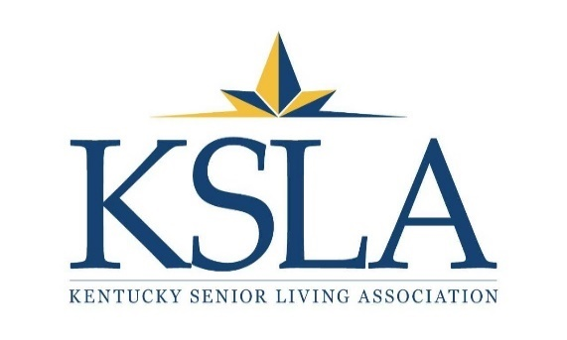
KSLA 2018 AWARDS NOMINATION PACKET
“Active Aging, the Cornerstone of Senior Living”

Dear KSLA Member,
We are very pleased to present your KSLA 2018 Awards Nomination Packet, with the exciting theme of “Active Aging, the Cornerstone of Senior Living.”
The four award categories are:
- Excellence in Civic Involvement
- Leadership
- Resident Lifetime Achievement
- Outstanding Caregiver

The first award is awarded to a company, and the other three awards are presented to individuals.
By design, the criteria are easy to understand, and the nomination forms are simple to complete. Nominations are open to all KSLA members, including assisted living, personal care, memory care, independent living, and associate members.
Judging is conducted by outside organizations, such as advocacy groups, business associations, and leadership consortiums. Award recipients will be recognized at KSLA’s 2018 Awards Celebration and Business Luncheon on May 31 at the Brown Hotel, Louisville, Kentucky, as well as at local presentations this summer, and throughout KSLA’s website and newsletter articles.
Thank you for your interest and participation! The deadline for all nominations is May 4, 2018. If you have any questions, please contact the KSLA office at KSLA@KentuckySeniorLiving.org or 502.938.5102.

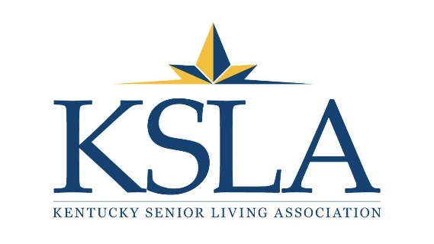

2018 EXCELLENCE IN CIVIC INVOLVEMENT AWARD NOMINATION FORM

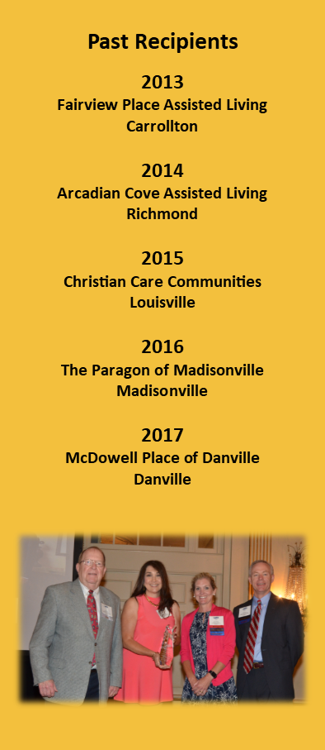
KSLA’s Excellence in Civic Involvement Award is based upon a company’s civic involvement in areas that may include, but aren’t limited to, volunteer roles, educational efforts, and similar activities for betterment of senior services in the Commonwealth. Each nominated company must be a KSLA provider or associate member.
Any KSLA member may participate by completing this form and returning it with the other required information. The deadline is May 4, 2018. Please mail your packet to KSLA at 133 Evergreen Road, Suite 212, Louisville, KY 40243. If you have questions, please contact the KSLA office at KSLA@KentuckySeniorLiving.org or call 502.938.5102.

Company Being Nominated: _______________________________
Contact Person for This Nomination: ________________________
Telephone Number of Contact Person: ______________________
Email Address of Contact Person: ___________________________

Please submit the following information, along with this nomination form, in sheet protectors that are neatly assembled:
- A narrative comprised of two to three double spaced typewritten pages in twelve-point font. Please describe the types of civic involvement activities that are conducted by the nominated company, and how those activities provide for the betterment of senior services.
- Supplemental materials that correlate with the narrative, such as newsletters, flyers, photographs, media clips, video footage, etc.
THANK YOU FOR PARTICIPATING!
2018 LEADERSHIP AWARD NOMINATION FORM

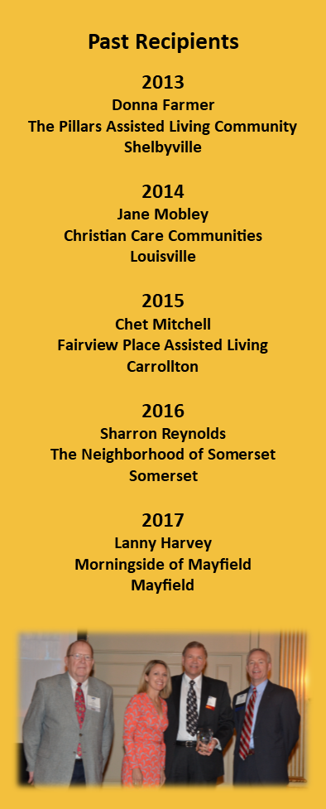
KSLA’s Leadership Award is based upon outstanding leadership demonstrated by an industry professional in areas that may include, but aren’t limited to, staff retention, established training programs, internal award and recognition programs, creating relationships of trust with clients and families, excellence in business management, quality service delivery, and professional involvement within his/her locality and industry. Each nominee must be an employee of a KSLA provider or associate member.
Any KSLA member may participate by completing this form and returning it with other required information. The deadline is May 4, 2018. Please mail your packet to KSLA at 133 Evergreen Road, Suite 212, Louisville, KY 40243. If you have questions, please contact the KSLA office at KSLA@KentuckySeniorLiving.org or call 502.938.5102.

Name of Nominee: ______________________________________
Contact Person for This Nomination: ________________________
Telephone Number of Contact Person: ______________________
Email Address of Contact Person: __________________________

Please submit the following information, along with this nomination form, in sheet protectors that are neatly assembled:

- A narrative comprised of two to three double spaced typewritten pages in twelve-point font. Please describe the outstanding leadership demonstrated by the nominee (i.e., staff retention, established training programs, internal award/recognition program, creating relationships of trust with clients and families, excellence in business management, quality service delivery and professional involvement within his/her locality and industry, etc.).
- Supplemental materials that correlate with the narrative, such as newsletters, flyers, photographs, media clips, video footage, etc.
THANK YOU FOR PARTICIPATING!
2018 RESIDENT LIFETIME ACHIEVEMENT AWARD NOMINATION FORM

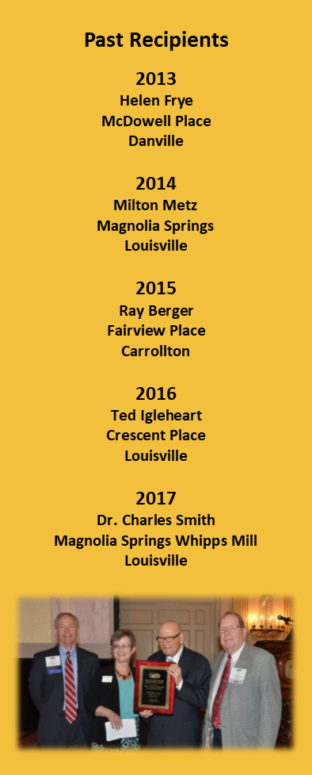
KSLA’s Resident Lifetime Achievement Award is based upon the significant lifetime contributions and achievements of a senior housing resident in areas that may include, but aren’t limited to, family civic, professional, military, education and church. Each nominee must be a resident of a KSLA provider member.
Any KSLA member may participate by completing this form and returning it with other required information. The deadline is May 4, 2018. Please mail your packet to KSLA at 133 Evergreen Road, Suite 212, Louisville, KY 40243. If you have questions, please contact the KSLA office at KSLA@KentuckySeniorLiving.org or call 502.938.5102.

Name of Nominee: ______________________________________
Contact Person for This Nomination: ________________________
Telephone Number of Contact Person: ______________________
Email Address of Contact Person: ___________________________

Please submit the following information, along with this nomination form, in sheet protectors that are neatly assembled:

- A narrative comprised of two to three double spaced typewritten pages in twelve-point font. Please describe the lifetime contributions and achievements of the nominee (i.e., family, civic, professional, military, education, church, etc.).
- Supplemental materials that correlate with the narrative, such as newsletters, flyers, photographs, media clips, video footage, etc.

THANK YOU FOR PARTICIPATING!
2018 OUTSTANDING CAREGIVER AWARD NOMINATION FORM

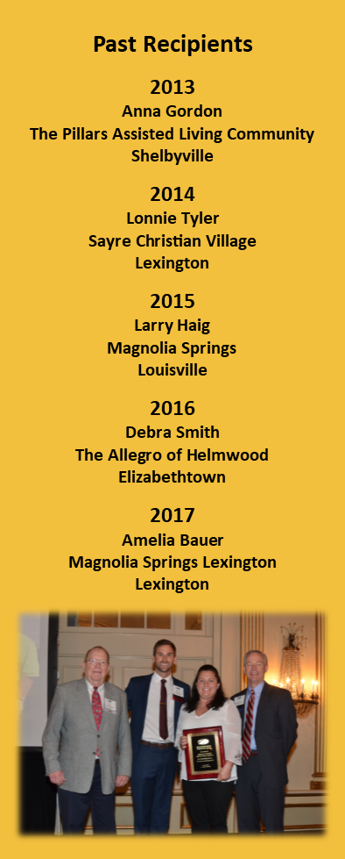
KSLA’s Outstanding Caregiver Award is based upon outstanding service, dedication and compassion demonstrated by a frontline employee in senior housing. Each nominee must be an employee of a KSLA provider member. All frontline employees, regardless of the department that are assigned, are eligible for nomination.
Any KSLA member may participate by completing this form and returning it with the other required information. The deadline is May 4, 2018. Please mail your packet to KSLA at 133 Evergreen Road, Suite 212, Louisville, KY 40243. If you have questions, please contact the KSLA office at KSLA@KentuckySeniorLiving.org or call 502.938.5102.

Name of Nominee: ______________________________________
Contact Person for This Nomination: ________________________
Telephone Number of Contact Person: ______________________
Email Address of Contact Person: __________________________

Please submit the following information, along with this nomination form, in sheet protectors that are neatly assembled:

- A narrative, comprised of two to three double spaced typewritten pages, in twelve-point font. Please describe the outstanding service, dedication and compassion demonstrated by the frontline caregiver whom you are nominating.
- Supplemental materials that correlate with the narrative, such as newsletters, flyers, photographs, media clips, video footage, etc.

THANK YOU FOR PARTICIPATING!

